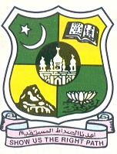
JAMAL MOHAMED COLLEGE (Autonomous)

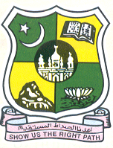
Accredited (3rd Cycle) with ‘A’ Grade by NAAC

(Affiliated to Bharathidasan University)

TIRUCHIRAPPALLI -620 020.

Since 1951

Maulana Abul Kalam Azad History Association of Jamal Mohamed College Tiruchirappalli takes pride in inviting you for the Celebration to 75 Years of Swaraj India Special Lecture Programme on 31th October, 2022, Monday at 11:00 A.M. at Commerce Gallery (Aided)

In the august presence of

Hajee M.J.Jamal Mohamed Bilal Dr. A.K.Khaja Nazeemudeen
President Secretary & Correspondent

Hajee M.J.Jamal Mohamed Dr.K. Abdus Samad Dr. K.N. Abdul Khadar Nihal
Treasurer Assistant Secretary Member & Hon. Director

Dr.S.Ismail Mohideen

Principal, Jamal Mohamed College
has kindly consented to preside over the function
Chief Guest
Thirukural.S. Muruganantham
Author- “Nadanthai Vazhi Tiruchirapalli”

delivers a special lecture on
“Freedom Fighters of Tiruchirappalli”

By

Dr.A.Mohamed Ibraheem Dr.M.Mohamed Sihabudeen
Vice Principal Additional Vice Principal

Dr.K.N. Mohamed Fazil Ms. J. Hajira Fathima

Director-Hostel Administration Director – Women Hostel
Will offer felicitations

Dr. M.MOHAMED TAJDEEN

Vice President

